

**MINI PROJECT**

**Geometric shapes its area and applications**

**Web Programming**

**(BCSE203E)**

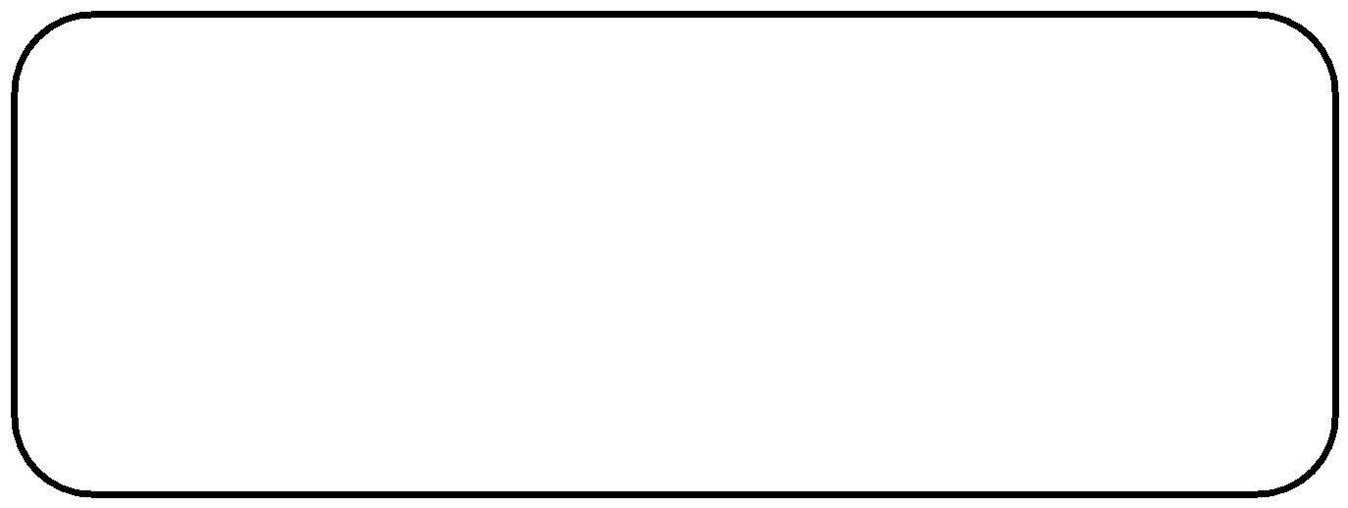

**Name** **: Jashwanth Vuppala**

**Reg. No : 22BCE0569**

**Slot** **: L45+L46+L51+L52**

**Faculty** **: Jayakumar K - SCOPE**

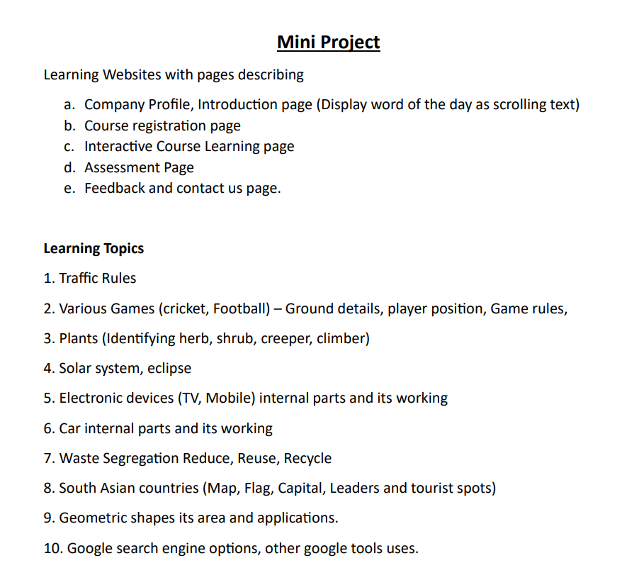

**Home Page**

<!DOCTYPE html>

<html>

  <head>

    <meta charset="UTF-8" />

    <meta name="viewport" content="width=device-width, initial-scale=1.0" />

    <title>Geometric Shapes: Area and Applications</title>

    <style>

      body {

        font-family: "Gill Sans", "Gill Sans MT", Calibri, "Trebuchet MS",sans-serif;

        margin: 20px;

        overflow: hidden;

      }

      header {

        text-align: center;

        background-color: #564caf;

        color: white;

        padding: 10px;

      }

      .introduction {

        margin: 10px 0;

        padding: 10px;

        background-color: #f2f2f2;

        border: 5px solid #ddd;

      }

      .companyProfile {

        margin: 10px 0;

        padding: 10px;

        background-color: #f2f2f2;

        border: 5px solid #ddd;

      }

      .scrollingword {

        position: absolute;

        bottom: 0;

        right: 100%;

        white-space: nowrap;

        font-size: 18px;

        color: red;

        animation: scrollText 15s linear infinite;

      }

      @keyframes scrollText {

        0% {

          right: 100%;

        }

        100% {

          right: 0;

        }

      }

    </style>

  </head>

  <body>

    <header>

      <h1>Geometric Shapes: Area and Applications</h1>

      <a href="./registrationpage1.html" style="color: yellow;">Click Here to Know more</a>

    </header>

    <article id="CompanyProfile">

      <h2>Company Profile</h2>

      <p>

        Math Marvels is an innovative online mathematics teaching platform

        dedicated to unlocking the magic within numbers. We believe that every

        learner can become a mathematical marvel with the right guidance. Our

        platform offers engaging and personalized lessons, designed to make math

        fun, accessible, and empowering. From foundational concepts to advanced

        problem-solving skills, Math Marvels is here to inspire a love for

        mathematics and foster a community of confident and capable learners.

        Join us on a journey where numbers transform into marvels, and learning

        becomes an exciting adventure. Welcome to the world of Math Marvels

        where math meets magic!

      </p>

    </article>

    <article id="introduction">

      <h2>Introduction</h2>

      <p>

        Welcome to the MathMarvels to enter into the fascinating world of

        geometric shapes, where lines, angles, and curves come together to

        create the building blocks of our visual reality. Geometric shapes are

        fundamental elements that play a crucial role in both mathematics and

        the world around us. From the simplicity of circles and squares to the

        complexity of polygons and polyhedra, these shapes provide the framework

        for understanding and describing our environment.

      </p>

      <p>

        Beyond the classroom, geometric shapes find practical applications in

        various fields. Architects use them to design structures that stand as

        feats of engineering and aesthetics. Artists incorporate geometric

        shapes into their creations, evoking harmony and balance. Engineers rely

        on geometric principles to design everything from machinery to

        electronic circuits. Even nature itself follows geometric patterns, from

        the hexagonal symmetry of honeycombs to the spirals of seashells.

      </p>

      <p>

        Join us on this journey as we unravel the secrets of geometric shapes,

        exploring their mathematical elegance and real-world significance.

        Whether you're a student embarking on a mathematical adventure or a

        curious mind eager to understand the world through shapes, this

        exploration promises to be both enlightening and inspiring. Let's embark

        on this geometric odyssey together!

      </p>

    </article>

    <img src="./geoimahe2.png" height="300" alt="List of geometric shapes" />

    <div class="scrollingword">

      Apollonian Gasket - is a fractal generated by recursively filling the gaps

      between three circles with smaller circles.

    </div>

  </body>

</html>

**Output**

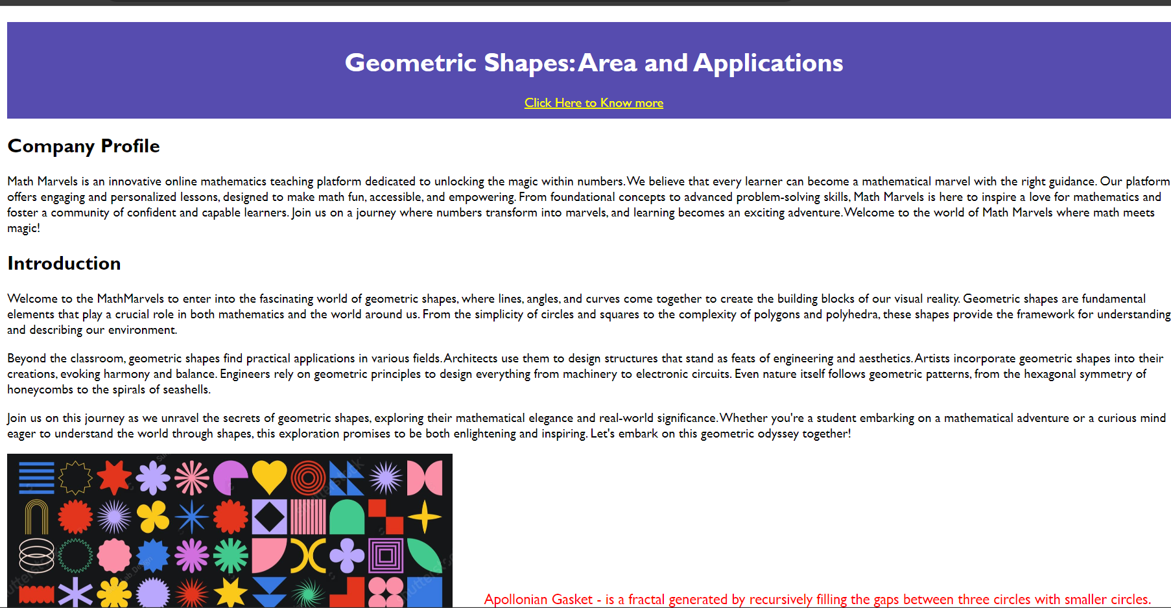

# Sign-in, Sign-up and Registration forms

**Sign-up :**

<!DOCTYPE html>

<html lang="en">

  <head>

    <meta charset="UTF-8" />

    <meta name="viewport" content="width=device-width, initial-scale=1.0" />

    <title>Sign up Page</title>

  </head>

  <body>

    <h1> Create an Account for free!</h1>

    <form id="signUpForm">

      <h2>Sign Up</h2>

      <label for="usernameSignUp">Username:</label>

      <input type="text" id="usernameSignUp" name="usernameSignUp" required />

      <br />

      <br />

      <label for="passwordSignUp">Create Password:</label>

      <input type="password" id="passwordSignUp" name="passwordSignUp" required />

      <br />

      <br />

      <label for="passwordSignUp">Confirm Password:</label>

      <input type="password" id="passwordSignUp" name="passwordSignUp" required />

      <br />

      <br />

      <button type="submit">Sign Up</button>

      <p style="color: red;">***Note: The password must contain 10 characters.It must contain minimum one lowercaseletter,uppercaseletter,number and special characters</p>

      <img src="./geoimage1.jpg" height="300"  alt="shapes">

      <br>

    <a href="./registrationpage2.html">Already Have an account? Click here to sign in</a>

    </form>

  </body>

</html>

**Output :**

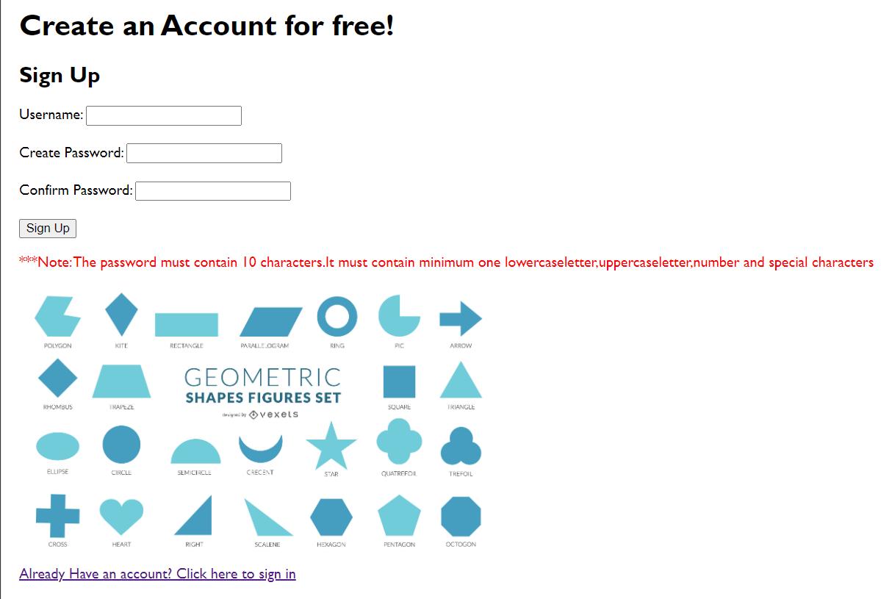

**Sign-in :**

<!DOCTYPE html>

<html lang="en">

<head>

    <meta charset="UTF-8">

    <meta name="viewport" content="width=device-width, initial-scale=1.0">

    <title>Sign in Page</title>

    <style>

        body {

    font-family: "Gill Sans", "Gill Sans MT", Calibri, "Trebuchet MS",sans-serif;

    margin: 20px;

    overflow: hidden;

  }

</style>

</head>

<body>

    <form id="signInForm">

        <h2>Sign In to Math Marvels</h2>

        <label for="usernameSignIn">Username:</label>

        <input type="text" id="usernameSignIn" name="usernameSignIn" required />

        <br />

        <br />

        <label  for="passwordSignIn">Password:</label>

        <input

          type="password" id="passwordSignIn" name="passwordSignIn" required />

        <br />

        <br />

        <button style="background-color: beige; border-radius: 20px; font-size: 20px; border-color: black

        ;"><a href="./registrationpage3.html" title="open

        ">submit</button></a>

        <br />

        <br />

        <img src="./marvels.png" height=300 alt="math marvels">

      </form>

</body>

</html>

**Output :**

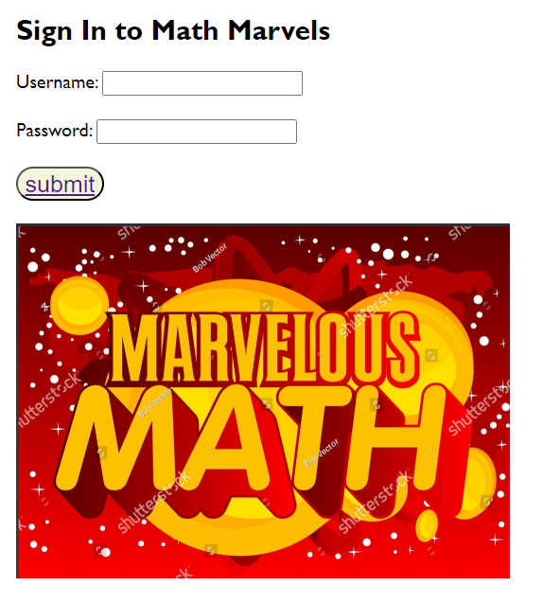

**Registration Page :**

<!DOCTYPE html>

<html lang="en">

<head>

    <meta charset="UTF-8">

    <meta name="viewport" content="width=device-width, initial-scale=1.0">

    <title>Registration form</title>

    <style>

        body {

    font-family: "Gill Sans", "Gill Sans MT", Calibri, "Trebuchet MS",sans-serif;

    margin: 20px;

    overflow: hidden;

  }

</style>

</head>

<body>

    <form id="registrationForm">

        <h2>Register our Course PLAYwithMATH for free!</h2>

        <label for="fullName">Full Name:</label>

        <input type="text" id="fullName" name="fullName" required />

        <br />

        <br />

        <label for="email">Email:</label>

        <input type="email" id="email" name="email" required />

        <br />

        <br />

        <label for="passwordRegistration">Password:</label>

        <input type="password" id="passwordRegistration" name="passwordRegistration" required />

        <br />

        <br />

        <button style="background-color: beige; border-radius: 20px; font-size: 20px; border-color: black

        ;"><a href="./learningpage.html" title="open

        ">submit</button></a>

        <br>

        <br>

        <img src="./geoimage3.png" alt="shapes">

</body>

</html>

**Output :**

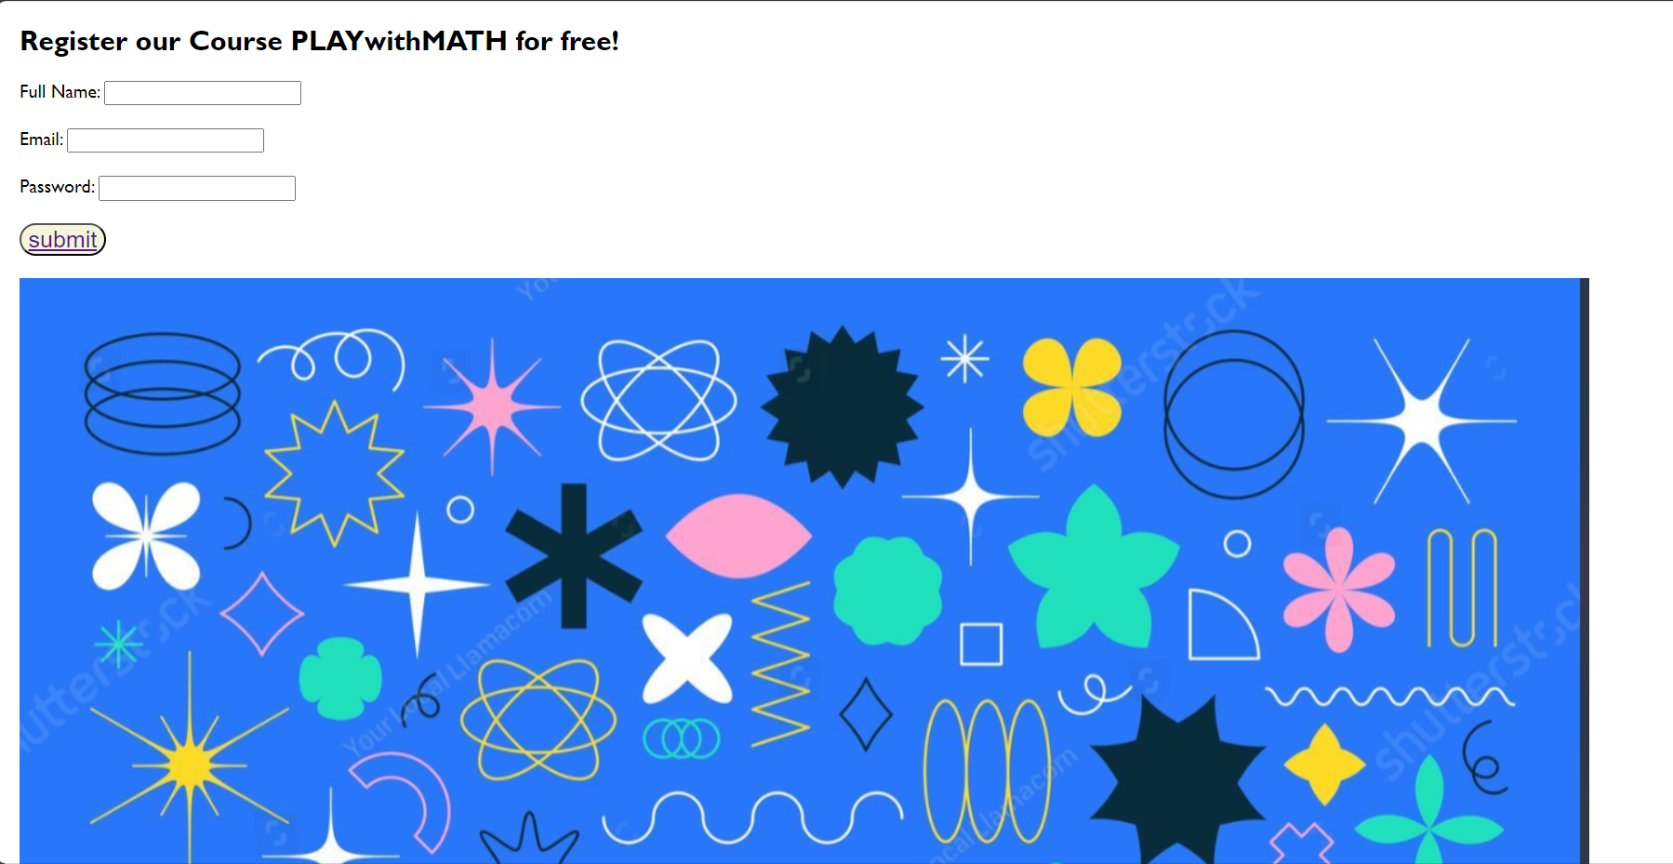

# Learning Page

<!DOCTYPE html>

<html lang="en">

  <head>

    <meta charset="UTF-8" />

    <meta http-equiv="X-UA-Compatible" content="IE=edge" />

    <meta name="viewport" content="width=device-width, initial-scale=1.0" />

    <title>learningpage</title>

    <style>

      * {

        padding: 0;

        margin: 0;

      }

      body

      {

        font-family: "Gill Sans", "Gill Sans MT", Calibri, "Trebuchet MS",sans-serif;

      }

      .heading {

        color: darkblue;

        font-size: 2.5rem;

      }

      header {

        display: flex;

        flex-direction: column;

        justify-content: center;

        text-align: center;

        background-color: lightskyblue;

        height: 15vh;

      }

      nav {

        display: flex;

        height: 5vh;

        background-color: black;

      }

      a:hover {

        background-color: white;

        color: black;

      }

      a {

        display: flex;

        flex-direction: column;

        justify-content: center;

        color: white;

        text-decoration: none;

        max-height: 100%;

      }

      .navbar {

        display: flex;

        gap: 20px;

        padding-left: 2%;

      }

      .box {

        float: left;

        width: 31.94%;

        padding: 10px;

        height: 500vh;

      }

      #box1 {

        background-color: silver;

      }

      #box2 {

        background-color: yellowgreen;

      }

      #box3 {

        background-color: teal;

      }

      .subheading {

        font-size: 2.5rem;

        padding-top: 10px;

        padding-bottom: 15px;

        display: flex;

        justify-content: center;

      }

      .para {

        display: flex;

        flex-direction: column;

        gap: 8px;

      }

    </style>

  </head>

  <body>

    <header>

      <div class="heading">Geometric shapes its areas and applications</div>

    </header>

    <nav>

      <div class="navbar">

        <a href="#">Basics about common shapes</a>

        <a href="#">Fun Facts</a>

        <a href="#">Applications</a>

        <a href="./quiz.html">It's Quiz Time</a>

      </div>

    </nav>

    <content>

      <div class="box" id="box1">

        <div class="subheading"><h5 style="color: green">Basics about common shapes</h5></div>

        <div class="para">

          <h3>Triangle:</h3>

          <img src="./Triangle.png" sizes="10" width="300" alt="Triangle">

          <p>

            <h4>Area of a Triangle (A):</h4> The area of a triangle is given by the

            formula A = (1/2) * base * height, where the base and height are

            perpendicular to each other.

            <br />

            <h4>Perimeter of a Triangle (P):</h4> The

            perimeter is the sum of the lengths of all three sides of the

            triangle, given by P = side1 + side2 + side3.

          </p>

          <hr />

          <h3>Rectangle:</h3>

          <img src="./rectangle.png" sizes="10" width="300" alt="Rectangle">

          <p>

            <h4>Area of a Rectangle (A):</h4> The area of a rectangle is given by the formula A = length * width, where length is the longer side, and width is the shorter side.

            <h4>Perimeter of a Rectangle (P):</h4> The perimeter is the sum of the lengths of all four sides, given by P = 2 * (length + width).

          </p>

          <hr />

          <h3>Square:</h3>

          <img src="./square.png" sizes="10" width="300"alt="square">

          <p>

            <h4>Area of a Square (A):</h4> The area of a square is given by the formula A = side * side, where side is the length of one side of the square.

            <h4>Perimeter of a Square (P):</h4> The perimeter is the sum of the lengths of all four sides, given by P = 4 * side.

          </p>

        </div>

      </div>

      <div class="box" id="box2">

        <div class="subheading"><h5 style="color: blue">Fun Facts</h5></div>

        <div class="para">

          <p>

            <h3>Pi Day Celebration:</h3>

            <img src="./pi.png" sizes="10" width="300"alt="pi">

            Pi (π) is an irrational number that represents the ratio of the circumference of a circle to its diameter. Pi Day is celebrated on March 14th (3/14), reflecting the first three digits of pi.

          </p>

          <hr />

          <p>

            <h3>Tetrahedron in Ancient Egypt:</h3>

            <img src="./pyramid.png"sizes="10" width="300" alt="pyramid">

            The ancient Egyptians considered the tetrahedron, a pyramid with a triangular base, as a symbol of the elemental substance of fire. They associated it with the concept of transformation and regeneration.

          </p>

          <p>

            <h3>Sierpinski Triangle:</h3>

            <img src="./sierpisnki.png" sizes="10" width="300"alt="sierpisnki triangle">

            The Sierpinski Triangle is a fractal named after the Polish mathematician Wacław Sierpiński. It is created by repeatedly removing smaller equilateral triangles from a larger one.

          </p>

        </div>

      </div>

      <div class="box" id="box3">

        <div class="subheading"><h5 style="color: white">Applications</h5></div>

        <div class="para">

          <p>

            <h3>Architecture and Design:</h3>

            <img src="./arc.png" sizes="10" width="300"alt="architecture">

            Architects and designers extensively use geometric shapes in their designs. Circles, squares, rectangles, triangles, and other shapes help create aesthetically pleasing and structurally sound buildings.

            Geometric shapes are employed in the design of floor plans, facades, and interior spaces. For example, circular windows, rectangular doors, and triangular roof structures are common design elements.

          </p>

          <p>

            <h3>Computer Graphics and Animation:</h3>

            <img src="./grahp.png" sizes="10" width="300"alt="graphics and animation">

            In the field of computer graphics and animation, geometric shapes are fundamental components for creating visual elements. 3D models, which form the basis of many digital animations and video games, are often constructed using geometric shapes.

            Algorithms for rendering and shading rely on geometric primitives like triangles and polygons to create realistic images on computer screens.

          </p>

          <p>

            <h3>Engineering and Manufacturing:</h3>

            <img src="./cad.png" sizes="10" width="300"alt="CAD">

            Engineers use geometric shapes in the design and analysis of mechanical components and structures. Circles, cylinders, and spheres are common shapes found in mechanical engineering designs.

            Computer-Aided Design (CAD) software facilitates the creation and manipulation of geometric shapes, aiding engineers in the design process. Geometric modeling is crucial in manufacturing for creating precise specifications for the production of parts and products.

          </p>

        </div>

      </div>

    </content>

  </body>

</html>

**Output :**

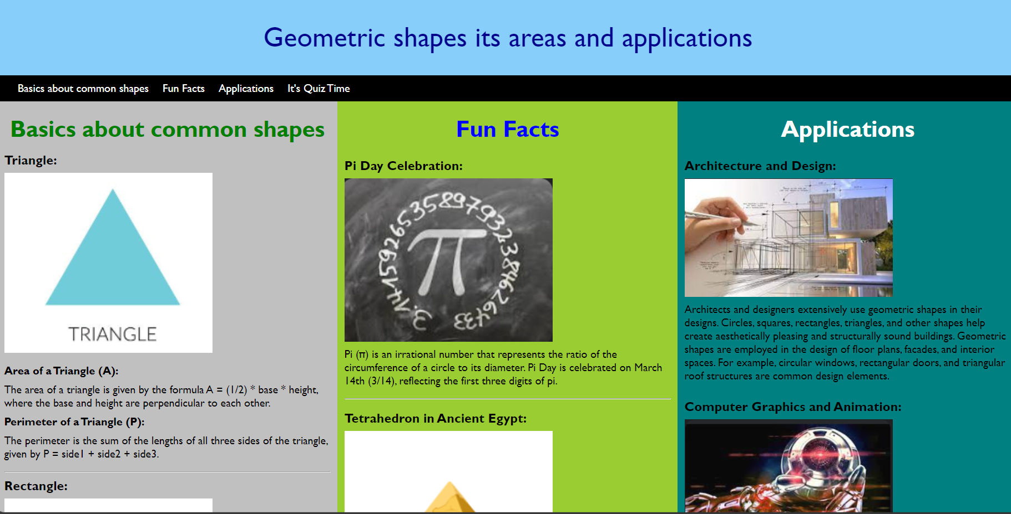

# Assessment Page

<!DOCTYPE html>

<html lang="en">

  <head>

    <meta charset="UTF-8" />

    <meta name="viewport" content="width=device-width, initialscale=1.0" />

    <style>

        body {

        font-family: "Gill Sans", "Gill Sans MT", Calibri, "Trebuchet MS",sans-serif;

        margin: 20px;

        overflow: hidden;

      }

      .container {

        display: flex;

        width: 100%;

      }

      .left-column {

        width: 50%;

        background-color: lightgray;

        padding: 20px;

      }

      .right-column {

        width: 50%;

        background-color: lightgreen;

        padding: 20px;

      }

      ul {

        list-style: none;

        padding: 0;

      }

      li {

        margin-bottom: 10px;

        padding: 5px;

      }

      .digital-assignment {

        background-color: lightcoral;

      }

      .written-exam {

        background-color: lightgreen;

      }

      .quiz {

        background-color: lightyellow;

      }

      h2 {

        margin-bottom: 10px;

      }

      h3 {

        font-style: italic;

      }

    </style>

    <title>Assessment Page</title>

  </head>

  <body>

    <div class="container">

      <div class="left-column">

        <h2>Questions</h2>

        <ul>

          <li class="digital-assignment">What is the name of a polygon with 11 sides?</li>

          <li class="written-exam"> If the measure of one exterior angle of a regular polygon is 40 degrees, how many sides does the polygon have?</li>

          <li class="quiz">In a right-angled triangle, if one acute angle is 30 degrees, what is the measure of the other acute angle?</li>

        </ul>

        <img src="./quizimggg.png" alt="haha">

      </div>

      <div class="right-column">

        <a href="./Feedback.html">Next</a>

        <h2>solutions</h2>

        <ul>

          <li class="digital-assignment">Undecagon</li>

          <li class="written-exam">Nine</li>

          <li class="quiz">60 degrees</li>

        </ul>

        <img src="./quizimg.png" alt="funquiz">

      </div>

    </div>

  </body>

</html>

**Output :**

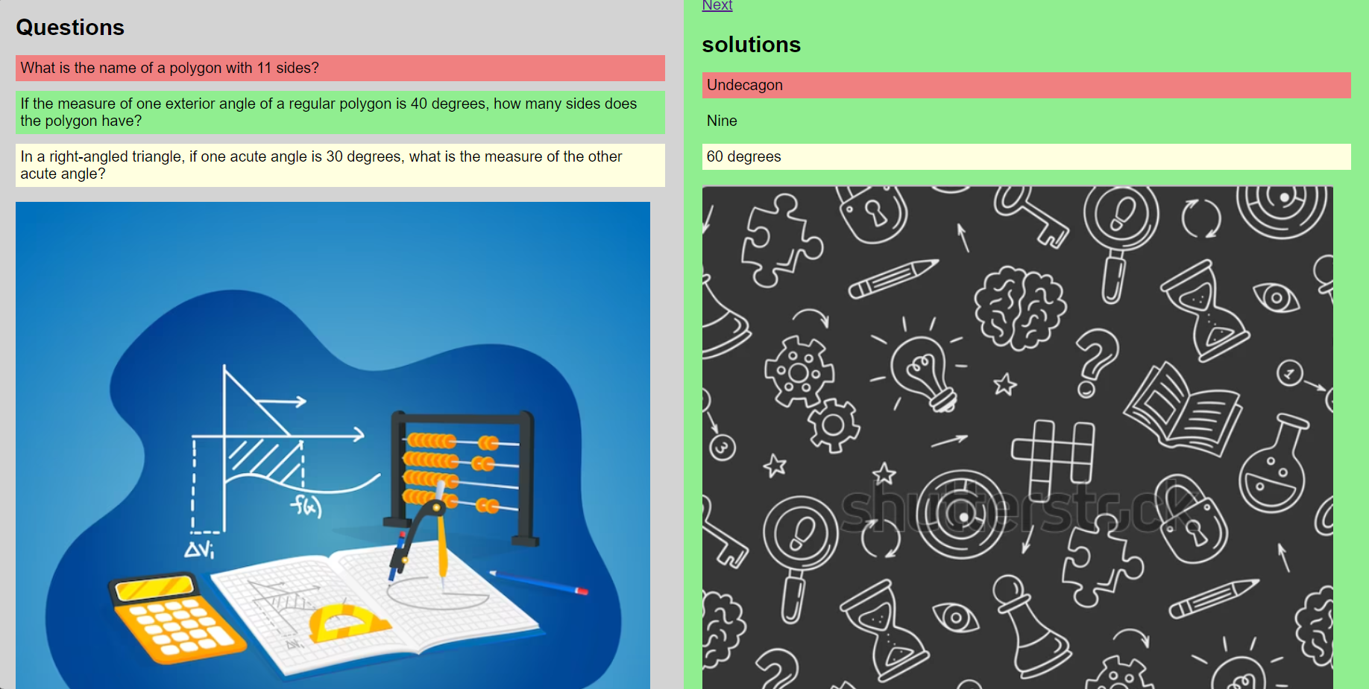

# Feedback Page

<!DOCTYPE html>

<html lang="en">

<head>

    <meta charset="UTF-8">

    <meta name="viewport" content="width=device-width, initial-scale=1.0">

    <title>Feedback Form</title>

    <style>

        body {

            font-family: "Gill Sans", "Gill Sans MT", Calibri, "Trebuchet MS",sans-serif;

            background-color: #f4f4f4;

            margin: 0;

            padding: 0;

            display: flex;

            justify-content: center;

            align-items: center;

            height: 100vh;

        }

        .feedback-form {

            background-color: #fff;

            padding: 20px;

            border-radius: 10px;

            box-shadow: 0 0 10px rgba(0, 0, 0, 0.1);

            width: 300px;

            text-align: center;

        }

        label {

            display: block;

            margin-bottom: 8px;

            font-weight: bold;

        }

        input[type="number"] {

            width: 100%;

            padding: 8px;

            margin-bottom: 16px;

            box-sizing: border-box;

        }

        textarea {

            width: 100%;

            padding: 8px;

            margin-bottom: 16px;

            box-sizing: border-box;

        }

        button {

            background-color: #4caf50;

            color: #fff;

            padding: 10px 20px;

            border: none;

            border-radius: 5px;

            cursor: pointer;

        }

        button:hover {

            background-color: #45a049;

        }

    </style>

</head>

<body>

    <div class="feedback-form">

        <h2>Feedback Form</h2>

        <form action="#">

            <label for="rating">Rate us (1-10):</label>

            <input type="number" id="rating" name="rating" min="1" max="10" required>

            <label for="comment">Your Views or Suggestions:</label>

            <textarea id="comment" name="comment" rows="4" required></textarea>

            <button type="submit">Submit Feedback</button>

        </form>

    </div>

    <img src="./feedback.png" alt="give feedback">

</body>

</html>

# Output

# 